North West Humanists Conference – 21 March 2015

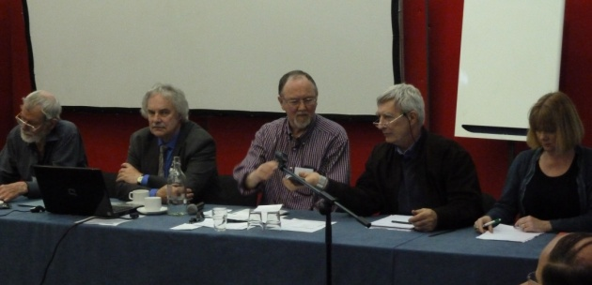
This one day conference organised by John Coss of GMH and Ian Abbot of LSH (Lancashire Secular Humanists) saw a good turn out and some engaging and entertaining sessions. The day ended with a Q&A involving all the speakers and chaired by Guy Otten (in the middle above).
What follows is a summary of the three speaker led sessions from the morning and after lunch speakers.

A Convenient Truth – a Better Society for Us and the Planet by Kate Pickett and Richard Wilkinson

The world is experiencing the effects of dramatic rising temperatures, e.g. deaths through flooding, drought and water shortages. It is estimated that 26 million people have been displaced by climate change. Naomi Klein in her book, This Changes Everything, talks about how the fossil fuel industry has infiltrated environmental groups, and often funds them, in an attempt to rubbish climate science. Also a lot of money is being pushed into politics to counter climate change concerns.
However there is evidence to show that the quality of life will improve through environmental sustainability measures. A graph was shown plotting life expectancy against carbon dioxide emissions per head for different countries. It demonstrated that many countries have high life expectancy at low levels of CO2 emissions, e.g. Cuba, Sweden and Costa Rica to name a few.
Another slide showed that life expectancy increases steadily with higher national income per head up to about $US20k but this relationship does not hold for the richer countries. Among the richer countries, income differences between the top 20% and the bottom 20% are greater in the UK and US than in Japan and the Scandinavian countries. Health and social problems are not related to national income per head but are worse in the more unequal societies.

Looking as to why this should be there is evidence that supports the view that material differences create social distance, such that where status is more evident, people become more concerned by it. A graph was shown illustrating that people undertaking tasks involving a ‘social evaluative threat’, in other words how you will be judged by your peers, have raised cortisol levels (a proven stress indicator). Other evidence showed that people who had a good circle of friends were less concerned with the effects of status, leading to the ‘convenient truth’ that, as indicators of wellbeing, material standards are less critical than general health, happiness and a good social environment. So it is that ‘social status’ and ‘friendship’ are the Jekyl and Hyde of general wellbeing in society.
The word companion comes from the adjunct of two Latin words: ‘con’ meaning with, and ‘pan’ meaning bread. So a companion was someone with whom you would happily share bread; therefore someone you trust. Another graph showed that where there is greater inequality in society people are less trusting of each other. Also there is greater violence, homicide and bullying.
Reactions to inequality are evident in various forms:
• Narcism
• Self enhancement
• Addictions
• Consumption and Consumerism
• Household debt
• Higher working hours
On the other hand in more equal countries people are more likely to recycle, and business leaders are more willing to comply with environmental measures. Also countries with a high proportion of trade union representation have lower inequality.
A graph showed that in the UK in the last century inequality was on a downward path until the 60s-70s after which it continued to rise up to the end of the last century. Trade union membership took the opposite path. Also the difference between the pay of CEOs and the lowest production worker in companies in the 1960-70s was about 20 fold.
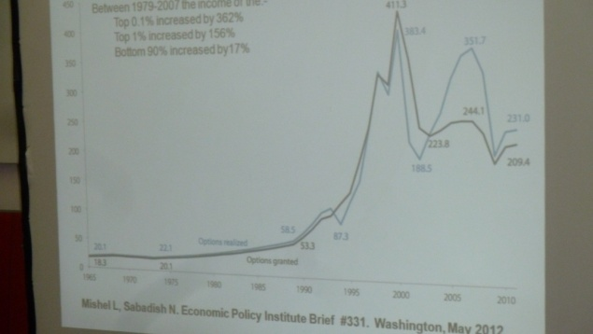
Now CEO pay is typically 200-300 times greater. It’s also the case that shareholders in the middle of the last century were more likely to have had a long term personal interest in the company whereas nowadays shares are traded daily, primarily by large institutions with no personal interest.
In conclusion the recommendation was to make changes to company boards to allow trade union representation and at a personal level to support only good companies.

~~~~~
Evolutionary and Compassionate Approaches to Humanism by Paul Gilbert
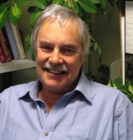
Compassion is defined as both sensitivity to suffering and a commitment to relieve it. In terms of psychologies it is a matter of a) ‘courage’ in order to understand how to engage with suffering and b) ‘competency’ in knowing how to alleviate it. Compassion is about compassion for others, compassion from others, and self-compassion. It involves the qualities of help, caring and giving and the competencies of paying attention and empathy. When received from somebody you don’t like, these same qualities and competencies can be seen as inhibitors to, as opposed to facilitators of, compassion.
There are no compassionate role models in society today; Nelson Mandela was probably the last. Today politicians talk about taking tough decisions, which is really about taking callous decisions. And there is evidence that the young are more focused on ‘self’ than before, resulting in more anxiety and depression in society.
Some of the causes of suffering today are to do with the way the human body and brain have evolved from old formulas of survival involving much suffering, disease, decay and injuries. (Religions used this to point to a hereafter as the only salvation.) We have evolved therefore to dissociate from a certain amount of fear, anger and grief which otherwise would result in depression.
Evolution it seems doesn’t create good designs. As the human body has evolved, the birth canal has shrunk while the head has become bigger. Thus evolution has compensated for an ability to stand upright by causing severe pain at childbirth.
Humans have certain biases: we are self-focused (narcissism) we have in-group preferences (tribalism) and kin preferences (nepotism). Humans quite like violence: Roman audiences had watched gladiators (trained killers) fighting (mainly slaves) in coliseums over a period of about 700 years. We are responsible for: torture, slavery, women as property, Chinese foot binding, FGM, domestic violence and concentration camps. We are also an obedient species (Fascism as an example). Our society facilitates the creation of leaders who are narcissistic, Machiavellian or psychopaths.
So what are the counters to these biases and human failings? As humans we also have ‘wisdom’, the ability to know thy self, live the moral life and show compassion. We can teach the nature of minds to others. We can care for others. It has been shown that being cared for improves our wellbeing as does caring for others. Whereas experiencing fear and anxiety impacts our physical health - what plays on your mind impacts your body, e.g. in terms of erotic thoughts, tiredness and weakness.
But by observing what’s going on in our minds we can start to control our primitive emotions. Motives as well as emotions are also able to organise our minds. The competitive mind for example is focused on me-ness, ownership, acting faster, the short-term and the ability to control. As opposed to the compassionate mind focused on we-ness, sharing, acting slower, the long-term and the ability to relate. It’s a contrast between blocking emotions and enabling emotions. It has been said that competitive managers are upward licking and downward kicking. Society in both schooling and work life is based on competitiveness.
There are essentially three systems of emotion:
- The threat system: self-protection and safety focused.
- The content, safe and connected system: focused on kindness, soothing and alleviating needs.
- The drive, excite and vitality system: focused on incentives, resources, wanting, pursuing and achieving.
The threat system causes more rumination and concern to us than the other two. It leads us to negative thinking. Politicians therefore play on this fact.

~~~~~
Why Humanists Should Care About Equality by Richard Norman

Equality is desirable for its own sake. The example was given of, on a small scale, an allotment shared with family members, all with equal shares in the allotment and in its products. Fairness though is different. It can be seen as fair to kill someone in war but not for personal reasons. Sometimes large institutions make us forget how inter-dependent we are; the ‘I did it all by myself’ attitude of some so-called ‘successful’ people is self-evidently not true.
In Rawls ‘A Theory of Justice’ (1972) he talks about these two themes of social cooperation (reciprocity) and individuality (distinctions between persons). He distinguishes between sacrificing for the greater good at an individual level and sacrificing for the social good. Humanism though is not just about social good, it also recognises the need for individualism.
There is a presumption of equal distribution of benefits and burdens unless there are good reasons for departures from equality. Such reasons might be:
- Needs: Some people’s needs are greater than others’. The underlying principle here is still equality.
- Contribution: If some people shoulder more of the burdens, it is fair that they should benefit correspondingly. Again the underlying principle is equality.
- Incentives: Rawls’s ‘difference principle’: inequalities are just only if they are to the advantage of the least well-off. These are inequalities which everyone can agree to. Example: income differentials provide incentives for people to work harder and use talents to the full, so that everyone benefits.
- Desert? Should some people get more because they deserve more? Yes, if it means compensation for greater contributions, or rewards as incentives. No, if it means those who are more talented are entitled to more.
- Freedom? An argument embraced by advocates of ‘the free market’. But ‘the free market’ does not promote the freedom of everyone. It makes some people much more powerful than others. Great inequalities of wealth create great inequalities of power. The power of the wealthy diminishes the real political freedom of the many.

A Convenient Truth “…Increases in economic democracy [are needed to] ensure that greater equality is more deep-seated in the fabric of society.” The converse is also true. Greater economic equality is needed in order to promote democracy and create a more equal distribution of power.

